**Module 7: Assignment 2: Server-side rendering with PUG Server**

Saurabh Verma

Arizona State University

IFT 598: Middleware Programming & Database Security

Professor. Dinesh Sthapit

November 12, 2022

Screenshot of config.env file with MongoDB credentials:

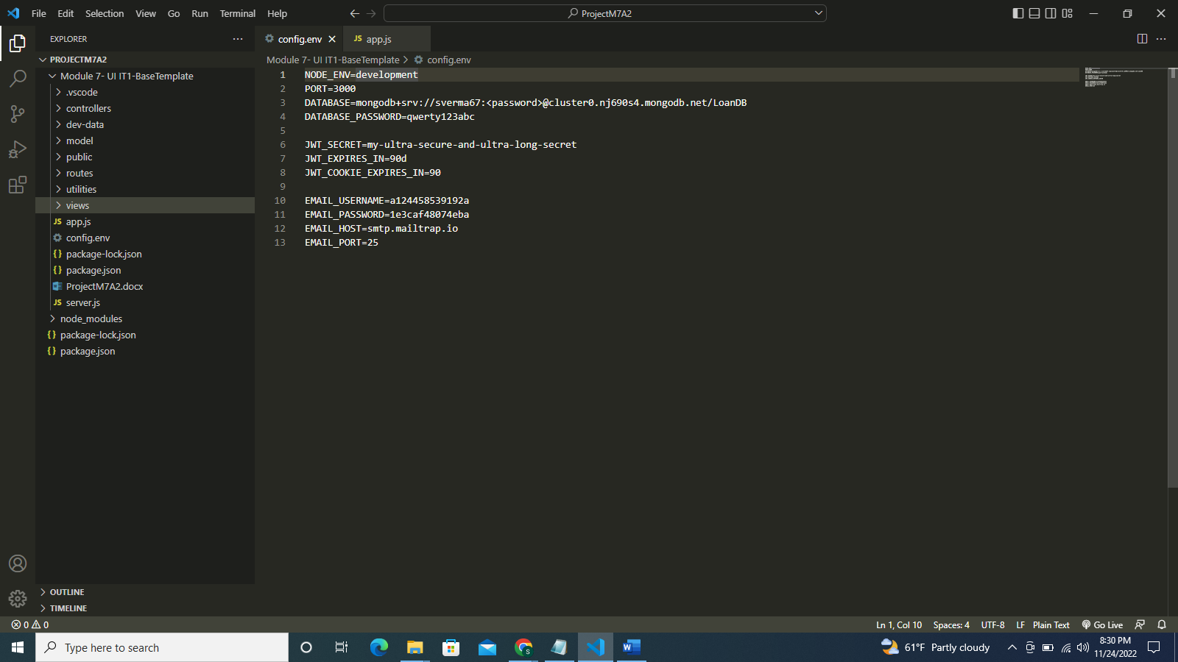

Screenshot of executable server.js file:

Screenshot of app.js file:

Screenshot of loanController.js file:

Screenshot of viewController.js file:

Screenshot of loanRoutes.js file:

Screenshot of viewRoutes.js file:

Screenshot of loanlist.html file:

Screenshot of courses.html file:

Screenshot of login.html file:

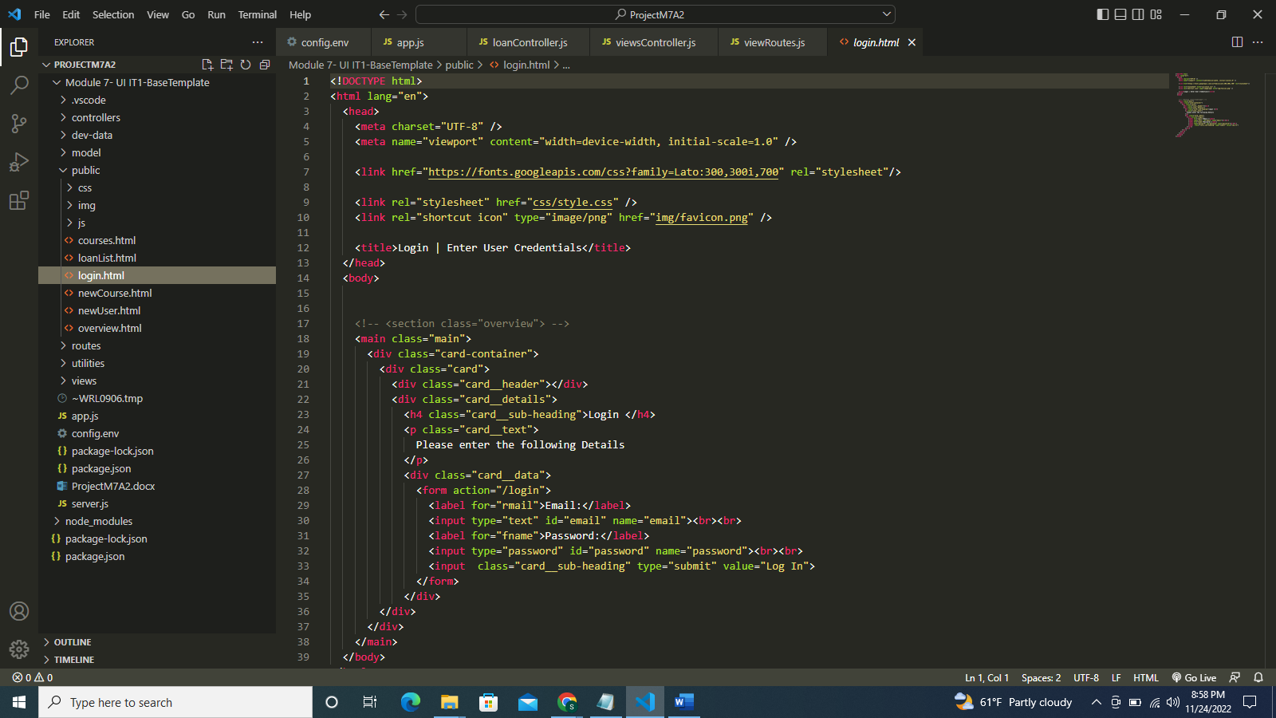

Screenshot of loanlist.pug file:

Screenshot of login.pug file:

Screenshot of of courses.pug file:

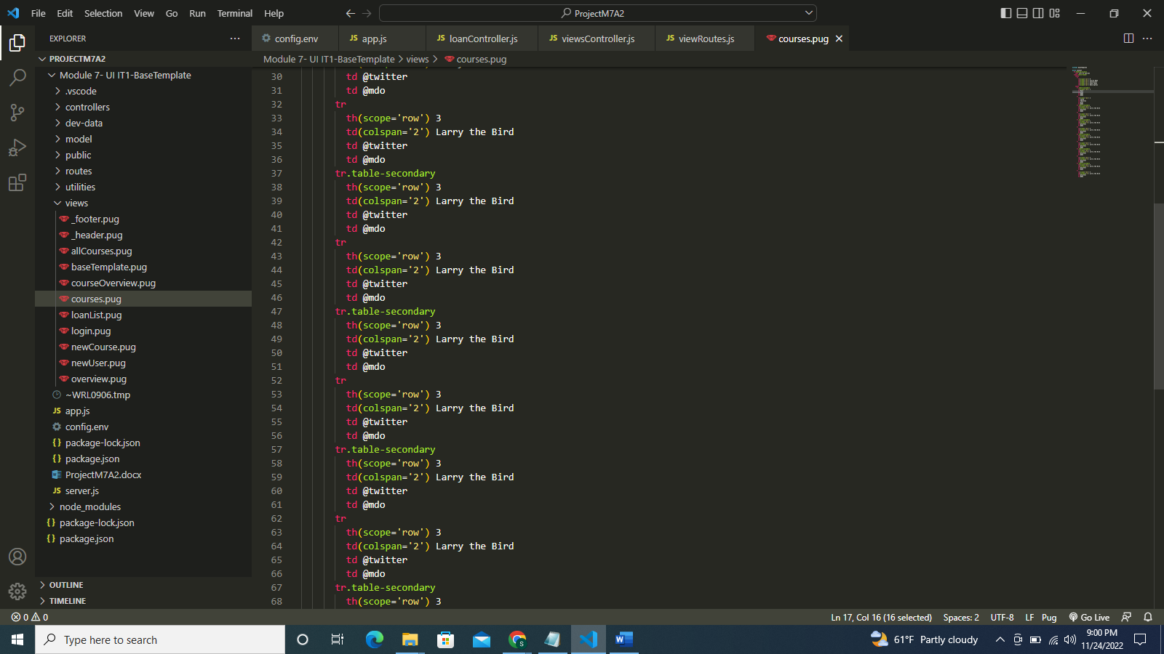

Screenshot of courses.json file:

Program running successfully and connection to DB is successful:

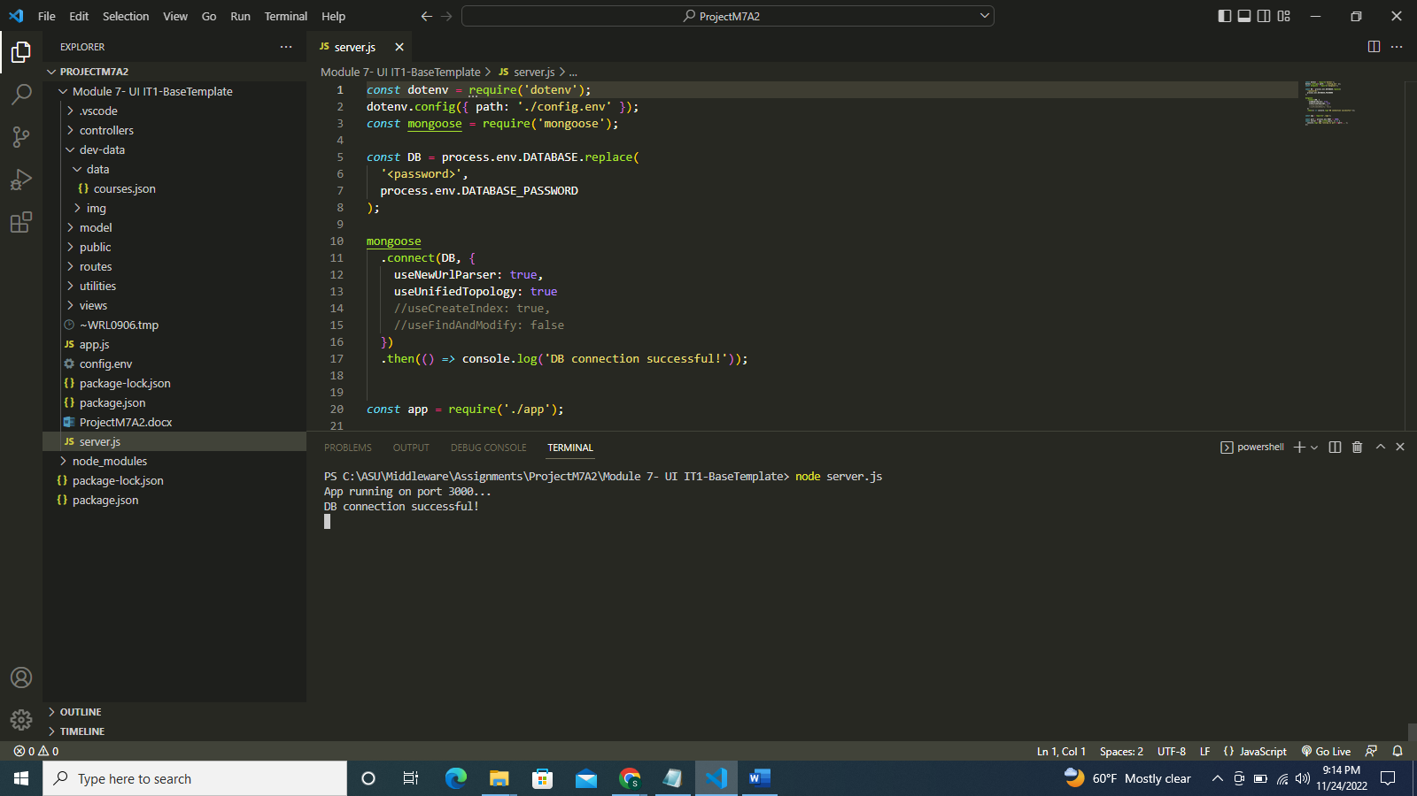

Screenshot of http://localhost:3000/api/v1/loans page:

Screenshot of http://localhost:3000/loanList page:

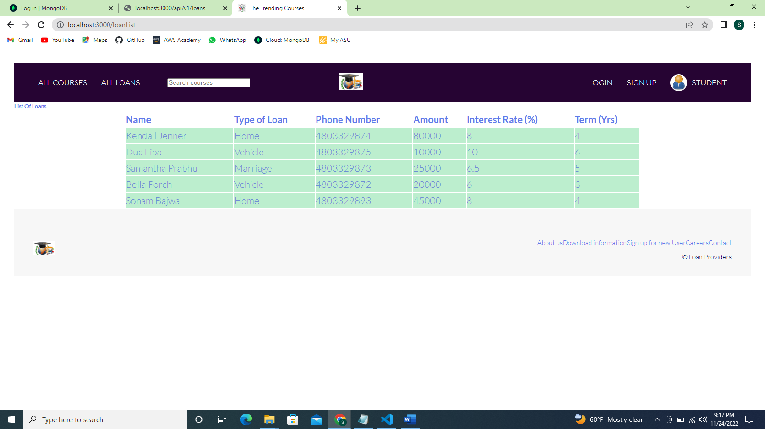

Screenshot of http://localhost:3000/courses page:

Screenshot of login page:

Screenshot of sign-up page:

Screenshot of new course page:

Screenshot of course list page:

**References**

GitHub repository:

[a-beginners-guide-to-pug](https://www.sitepoint.com/a-beginners-guide-to-pug/)